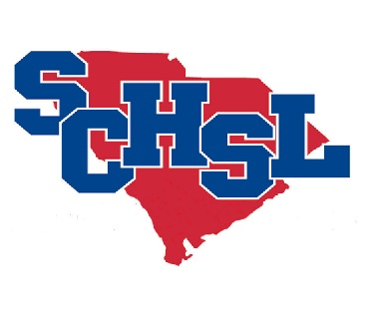 | MULTI-SPORT ATHLETE NOMINATIONS

The League is pleased to sponsor a Multi-Sport recognition program. The purpose of this recognition program is to promote multi-sport participation in the athletic culture.

The “Double Threat” award was launched to recognize those students in our member schools who letter in at least two varsity SCHSL sanctioned sports.

All nominees must meet the following criteria:

- Must have lettered in two varsity sports during 2021-22 school year.

Please email the form with Principal’s Signature to Jan jan@schsl.org

It is important that all nominations be submitted to the League Office by APRIL 15, 2022.

We hope to have personalized certificates for each qualifying student athlete to the school by May 15, 2022. Therefore, our time schedule is tight.

If you have any questions, please call the League Office.

MULTI-SPORT ATHLETE NOMINATIONS

(Due on or before April 15, 2022)

SCHOOL:

MUST BE TYPED.

The following students meet the qualifications to be recognized by the South Carolina High School League as a “Double Threat” Athlete for the 2021-22 school year. Please email this list to jan@schsl.org

NAME |  | SPORT(S) PLAYED

Principal Athletic Director

