Sanctioning system instructions

The South Carolina High School League has created a new system for sanctioning. The system is all digital and will replace the current system on Jan. 1, 2022. You will have the option of using the new system or the old system until Jan. 1, 2022.

You will need to create an account to access the new system.

Go to the website https://schsldirectory.knack.com/sanctioning and click the Sign Up button on the bottom of the page.

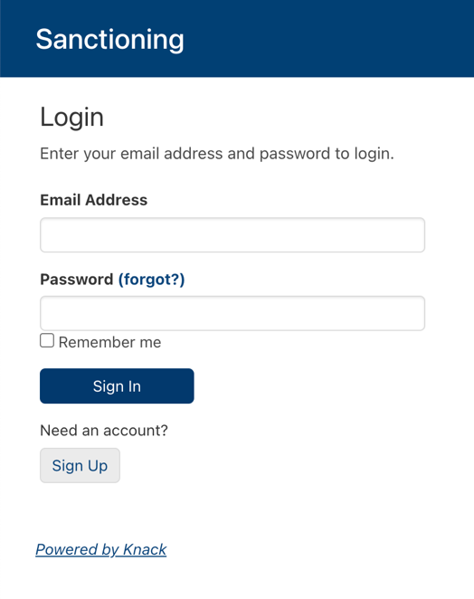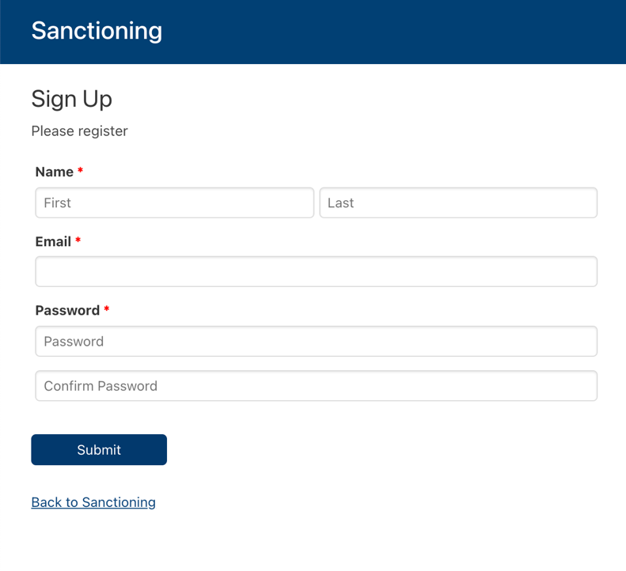

Fill in the blanks on the Sign Up page and click the Submit button to create your account.

You will need to press the “Back To Sanctioning” link on the page that appears to log in to the account that you just created.
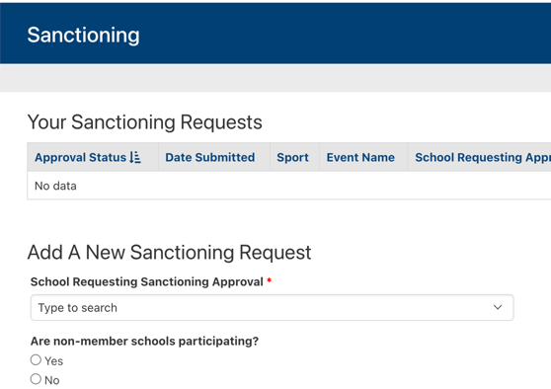
When you log in, you will see two areas of the window. The top section is a list of sanctioning requests that you have submitted. It will be blank the first time you log in. After you complete the first form, it will appear in the top section. You will be able to track the request as it goes through the approval process.

To start a new sanctioning request, begin filling out the section that is labeled “Add A New Sanctioning Request.

The first part of the request deals with the event. You will need to input your school’s name in the first field, then answer the questions that are related to the event, such as sport, event type, start date, end date, etc. You will need to include your principal’s name and email address. A link will be sent to your principal, who must then sign off on the event before it will be processed. Make sure you inform the principal that an email will be sent.

At the bottom of the section, there is a button that allows you to go to part 2 of the application process. Part 2 will largely deal with the teams that are participating in the event.

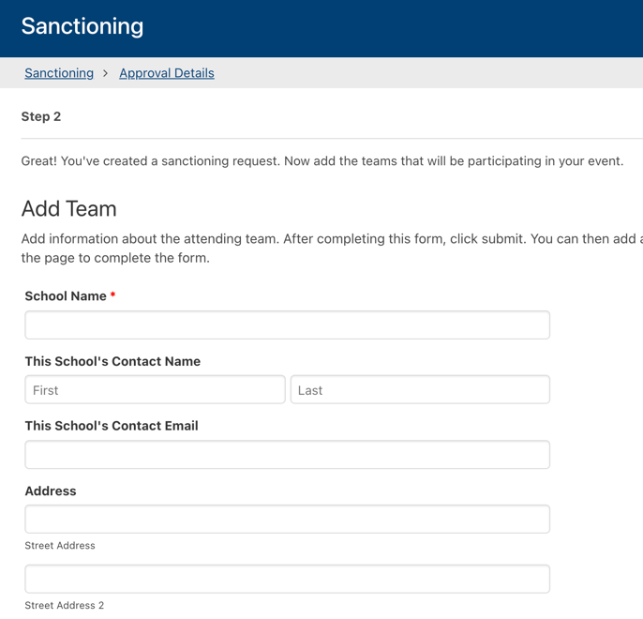
Complete the information requested about the team. You will need to indicate if the team is in state or out of state. If out of state, you will need to indicate which state. If you know the sanctioning body that oversees the team, please indicate it in the dropdown list. This information will be sent to the state association in charge of that school. The state association will approve or reject the team’s participation in the event.

After completing the form, click the Add This Team button. Then repeat part 2 for every team participating in the event. A list of all of the teams you have entered will be available below the Add Team section.

When you have added all of the teams in the event, you can submit the form. Go to step 3 at the bottom of the page and click Submit. You will be taken to a summary page where you can print the details of your application if you like. Your principal will be emailed with a link to this application. The principal will need to create an account before clicking the link. After the account is created, the principal can click the link to be taken to the details of the event. After signing the approval form, the request will be sent to the SCHSL.

After the governing body for each attending team rules on the application, the SCHSL will rule on the application and an alert will be sent to the person who requested approval of the event.

