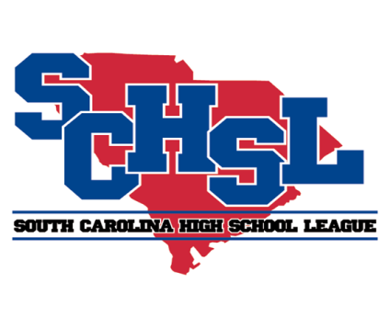 | South Carolina High School League  PO Box 211575  Columbia, SC 29221-6575  803-798-0120  www.schsl.org

Football Passing League Reporting Form

 | Date |  | Opponent(s) |  | Site
1
2
3
4
5
6
7
8
9
10

Reminder
Member schools will be permitted 10 days of competition in summer leagues, team camps, or other outside organizations during the time period of June 1 through July 25. They may use school facilities and equipment for these 10 days. The exact 10 days must be documented by date and records of these days supplied to the League Office.

School Principal’s Signature

Please email to schsl@schsl.org no later July 31

