Updating the SCHSL Directory

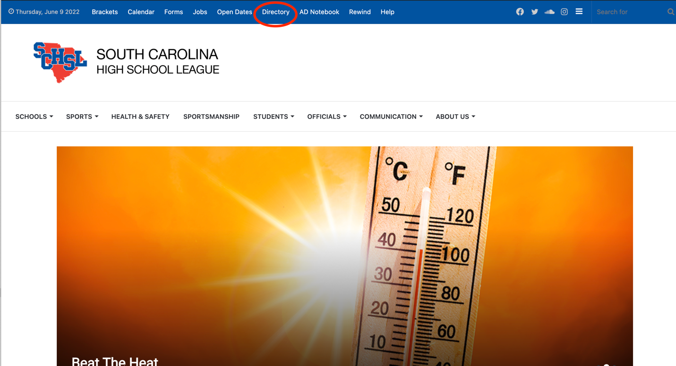

Go the SCHSL website and click the Directory menu at the top of the page.
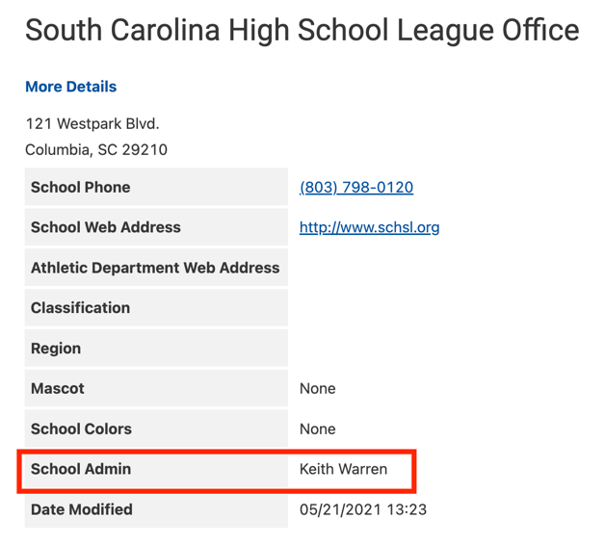
Search for your school. Near the bottom of the listing, you will see the label School Admin.

The name to the right of that label is the current admin for this listing.

You can ask your school directory admin to make any changes.

You may also request that a different staff member to be the admin or request additional people to be administrators by emailing Keith Warren at keith@schsl.org.

To access the directory, please go to this URL: https://schsldirectory.knack.com/school-directory-dev

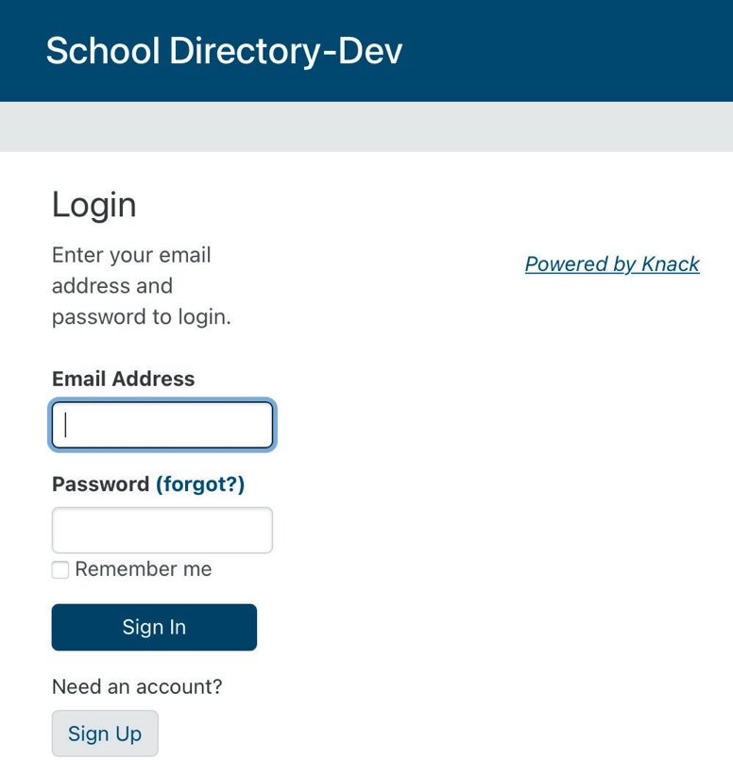
If you have an SCHSL Directory account, you can log in using your username and password.

If you do not have an account, you will need to create one using the Sign Up button at the bottom of the page. After you create the account,

DO NOT create a new school. Submit an email using the link above to request access (please include your school name).

After you receive a confirmation email that you have been added to your school, you may proceed.

When you log in, you will see a screen similar to the one shown below.

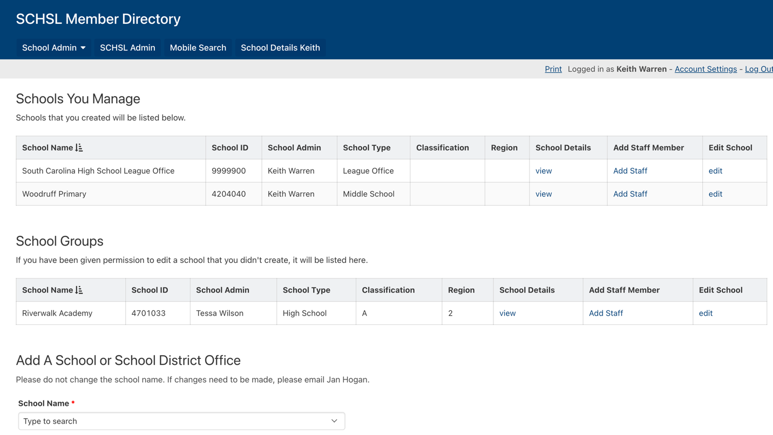
If you created a school, it will show in the top portion of the window under Schools You Manage. If you have been added as an administrator, the school(s) will be listed in the School Groups area.

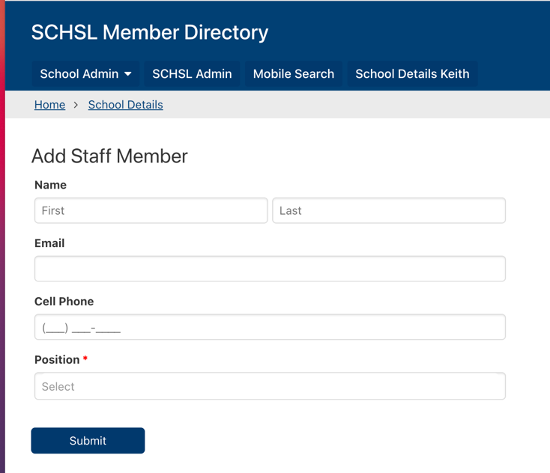
Click the link under Add Staff Member to make any adjustments to the school staff.

In the top section, you can add any new staff members to the directory.

You should enter the school principal, athletic director, assistant athletic director, athletic director administrative assistant and all head coaches.

When you enter the school administration, athletic director, assistant AD, and AD administrative assistants, their email addresses are automatically added to the appropriate SCHSL email groups. So please make sure the email addresses are correct.

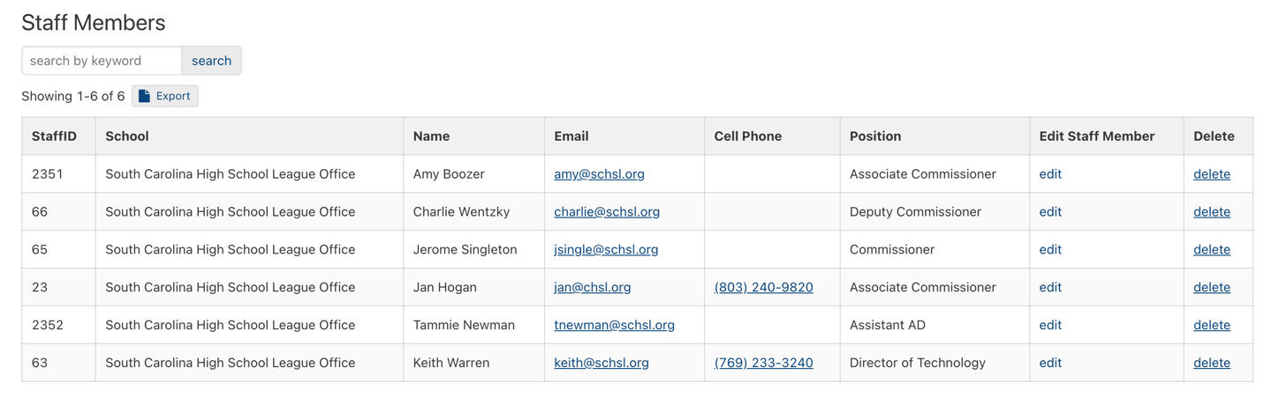To make changes to staff members who are already in the directory, click the Edit Staff Member link for the appropriate person. To remove a person from the directory, click the Delete link.

