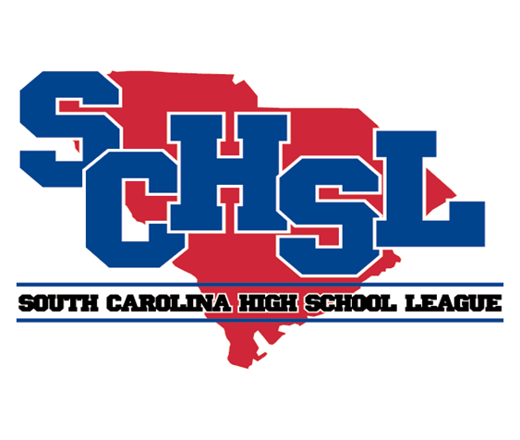 | SOUTH CAROLINA HIGH SCHOOL LEAGUE  PO Box 211575  Columbia, South Carolina 29221-6575  803-798-0120  www.schsl.org
To: Athletic Directors with Competitive Cheer Teams
From: Amy Boozer, Associate Commissioner
Subject: Class AAA State Cheer Qualifying
Date: November 1, 2024

AAA Cheer Qualifying will take place at
Lexington High School on November 9, 2024

The number of teams who qualify for the state finals will be 3/4 of the total number of teams who compete at the statewide qualifier. The number cannot exceed 16 to advance to state.

11:00……..Walhalla  11:07……..Ninety Six  11:14……..Waccamaw  11:21……..Liberty  11:28……..Mountain View  11:35……..Southside Christian  11:42……..Cheraw  11:49……..Chapman  11:56……..Palmetto  12:03……..Broome  12:10……..Woodruff  Break | 12:25 Chesnee  12:32 Fox Creek  12:39 Mid-Carolina  12:46……Batesburg-Leesville  12:53 Hanahan  1:00 Powdersville  1:07 Lewisville  1:14 Abbeville  1:21 Belton-Honea Path  1:28 ……Clinton  1:35…….Academic Magnet
Please E-mail a complete roster and a team picture if you did not send one with your notification of entry to be used by our corporate sponsor and be used in the online program for STATE by

Friday, November 15.

brooke@schsl.org

Please put the school’s name in the subject line of the email.

