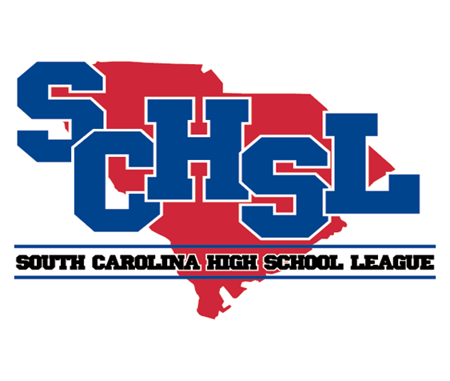 | SOUTH CAROLINA HIGH SCHOOL LEAGUE  PO Box 211575  Columbia, South Carolina 29221-6575  803-798-0120  www.schsl.org
To: Athletic Directors with Competitive Cheer Teams
From: Amy Boozer, Associate Commissioner
Subject: Class AAAA State Cheer Qualifying
Date: November 6, 2024
A

AAAA – Cheer Qualifying will take place at
Airport High School November 13, 2024

The number of teams who qualify for the state finals will be 16. Scores will be emailed to the coaches at the conclusion of the contest and later posted on the League’s website.

Session I (Spectators will need to leave after session) Session II
6:00 Westside  6:07 Midland Valley  6:14 Lower Richland  6:21 Hilton Head Island  6:28 Hartsville  6:35 Seneca  6:42 Fountain Inn  6:49……. Travelers Rest  6:56……. Gilbert  7:03 May River  7:10 Blue Ridge  7:17 …… Airport  Break | 7:32 …... Dreher  7:39 South Florence  7:46 York Comprehensive  7:53 Wren  8:00 Brookland-Cayce  8:07 Colleton County  8:14 Laurens District 55  8:21 Daniel  8:28 Bishop England  8:35.…… A.C. Flora  8:42……. Gray Collegiate  8:49……. Wilson

Please E-mail a complete roster and a team picture if you did not send one with your notification of entry to be used by our corporate sponsor and be used in the on-line program for STATE by

Friday, November 15

brooke@schsl.org

Please put school name in subject line of email.

