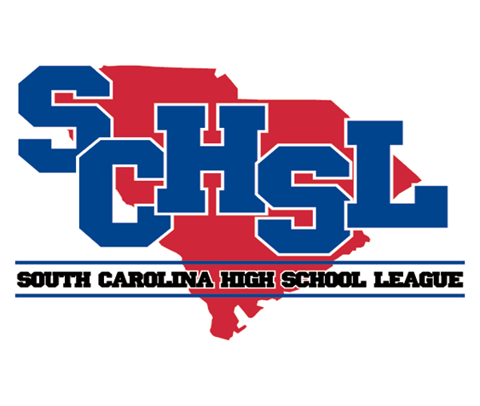 | SOUTH CAROLINA HIGH SCHOOL LEAGUE  PO Box 211575  Columbia, South Carolina 29221-6575  803-798-0120  www.schsl.org
To: Athletic Directors with Competitive Cheer Teams
From: Amy Boozer, Associate Commissioner
Subject: Class AAAAA – Division I State Cheer Qualifying
Date: November 6, 2024
A

AAAAA – Division I Cheer Qualifying will take place at
White Knoll High School November 14, 2024

The number of teams who qualify for the state finals will be 12. Scores will be emailed to the coaches at the conclusion of the contest and later posted on the League’s website. Performance order for state will be based on the team’s results from qualifiers.

6:00 Fort Dorchester  6:07 Wando  6:14 Boiling Springs  6:21 Byrnes  6:28 Wade Hampton  6:35 West Ashley  6:42 Carolina Forest  6:49……. Dutch Fork  6:56……. James Island  7:03 Rock Hill  7:10 Clover  Break | 7:25 …... Lexington  7:32 …... Cane Bay  7:39 River Bluff  7:46 Ridge View  7:53 Summerville  8:00 Dorman  8:07 Ashley Ridge  8:14 Blythewood  8:21 Mauldin  8:28 Spring Valley
Please E-mail a complete roster and a team picture if you did not send one with your notification of entry to be used by our corporate sponsor and be used in the on-line program for STATE by

Friday, November 15

brooke@schsl.org

Please put school name in subject line of email.

