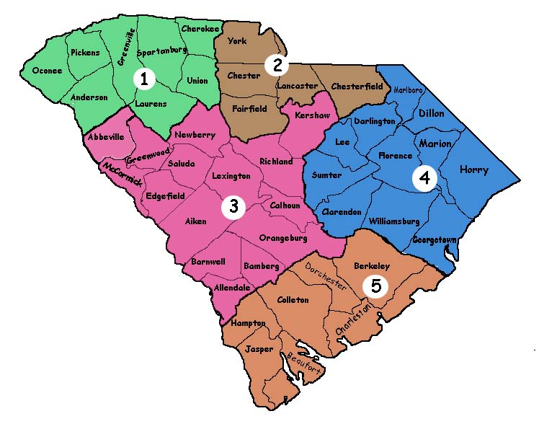
District 1/Upstate – Chris Broome
District 2/Piedmont – Robbie Compton
District 3/Mid State- Andy Rutledge
District 4/Beach - Jeff Chatlosh
District 5/Low Country - Chris Van Metre

